
Jaypee University of Information Technology, Waknaghat Solan H.P

Solution Sheet
Shortest Path Algorithms

Q1) Answer: a
For a directed acyclic graph (DAG), the fastest known algorithm for single-source shortest paths uses the following two steps: (1) compute a topological ordering of the vertices in $Θ\left(m+n\right)$time, then (2) process vertices in that topological order, relaxing every outgoing edge of each vertex exactly once, which takes $Θ\left(m+n\right)$ time in total (this correctly computes shortest paths since, in topological order, all edges into a vertex are relaxed before that vertex is finalized, and no negative cycles can exist in a DAG so ordinary Dijkstra-style priority queues or Bellman-Ford repeated relaxation are unnecessary).
This is strictly faster than Dijkstra's $Θ\left(m+n\log{n}\right)$(needed only for general graphs with a priority queue) or the $Θ\left(nm\right)$Bellman-Ford bound (needed for general graphs, possibly with negative edges but no negative cycles) — the DAG structure lets us avoid both.

Q2) Answer: a
d_{k​}(u) is the shortest-path weight from $s$to $u$using at most $k$edges — this is exactly the quantity computed by the Bellman-Ford relaxation process after $k$rounds.
S1: $d_{k+1}\left(u\right)≤d_{k}\left(u\right)$— allowing one extra edge of "budget" can only give access to more paths (a path of length $≤k$is also a path of length $≤k+1$), so the shortest weight can only stay the same or decrease. True, always.
S2: Suppose $\left(u , v\right)$lies on a shortest path from $s$to $v$; then $d\left(v\right)=d\left(u\right)+w\left(u , v\right)≥d\left(u\right)$in the limit, so eventually $d_{k}\left(u\right)≤d_{k}\left(v\right)$once $k$is large enough. But for small $k$ this need not hold: it's possible that $u$has not yet been reached with a short enough path (so $d_{k}\left(u\right)=∞$is even bigger) or, more subtly, that a different, cheaper path of length $≤k$ to $v$exists that doesn't go through $u$at all — the inequality can fail for some particular $k$ even though it eventually holds in the limit. So S2 is not always true for every $k$.

Q3) Answer: c
Adding the same positive constant $α$to every edge shifts the total weight of any spanning tree by exactly $α×\left(n-1\right)$(since every spanning tree has exactly $n-1$edges, the same count) — a uniform shift that doesn't change which spanning tree has the minimum total weight. So every MST remains an MST.
Shortest paths, however, can use a different number of edges depending on the route — a path with fewer edges gets a smaller total addition of $α$than a path with more edges, which can flip which path is actually shortest after the update. So SPs need not remain SPs.

Q4) Answer: c
Let the diameter of the graph be the maximum shortest distance between any two vertices.
It is given that $\max_{u,v∈V,u≠v}d\left(u , v\right)=30.$
Thus, the diameter of the graph is 30.
Relation between BFS Tree Height and Graph Diameter
A Breadth-First Search (BFS) tree rooted at a vertex (r) has the following property:
- The level of every vertex equals its shortest distance from the root.
- Therefore, the height of the BFS tree is the maximum shortest distance from the root to any vertex, which is called the eccentricity of the root.
Let the height of the BFS tree be (h). Then, $h=\max_{v∈V}d\left(r , v\right).$
Using the Diameter
Let the diameter of the graph be (D=30). A well-known property of graphs is $\text{Radius}≥\left\lceil \frac{D}{2}\right\rceil .$
Since $D=30,$we get $\left\lceil \frac{30}{2}\right\rceil =15.$
Every vertex has eccentricity at least the radius. Hence, regardless of the chosen BFS root, $h≥15.$
The height need not be exactly 15 or exactly 30. It can be any value between 15 and 30 depending on the chosen root.
For example:
- If the BFS starts from a central vertex, the height can be 15.
- If it starts from an end vertex of a diameter, the height can be 30.

Q5) Answer: a
Checking each statement:
- (I): distinct weights $⇒$unique MST True
- (II): two different paths can have equal total weight even with distinct edges (e.g. 1 + 4 = 2 + 3) False

Q6) Answer: 12
Without edge {3, 4}, the shortest path from 3 to 4 is 3-2-1-4 = 5 + 2 + 5 = 12.
The edge of weight x lies on a shortest path (at least one, possibly tied) only if $x≤12$. The largest integer is 12.
Q7) Answer: c
Bellman-Ford takes $Θ\left(V E\right)$. A complete graph has $E=Θ\left(n^{2}\right)$.
$$n×n^{2}=Θ\left(n^{3}\right)$$

Q8) Answer: SACET
Dijkstra from S: B = 3, A = 4, D = 7 (via S).
- Pop B: D via B = 7, not strictly shorter, so D keeps parent S.
- Pop A: C = 5. Pop C: E = 6 (D via C = 8, no change).
- Pop E: T = 10 (via E), G = 8.
- Pop D: T via D = 10, not strictly shorter, so T keeps parent E.
Path: S $→$A $→$C $→$E $→$T

Q9) Since all edges have weight 1, we use BFS (Breadth First Search) to find the shortest path.
We mark a node visited when it is inserted into the queue.
Step | Dequeued | Newly visited (enqueued) | Queue after operation
0 | — | 0 | [0]
1 | 0 | 1, 3 | [1, 3]
2 | 1 | 2 | [3, 2]
3 | 3 | 4 | [2, 4]
4 | 2 | 6 | [4, 6]
5 | 4 | 5 | [6, 5]
6 | 6 | 7, 8 | [5, 7, 8]
7 | 5 | None | [7, 8]
8 | 7 | None | [8]
9 | 8 | None | []
Construct shortest path using parent array
Whenever we insert a new vertex, record its parent.
Vertex | Parent
0 | NIL
1 | 0
3 | 0
2 | 1
4 | 3
6 | 2
5 | 4
7 | 6
8 | 6
Now trace backwards from 8:
8<- 6<- 2<- 1<- 0
Therefore path:
0 -> 1 -> 2 -> 6 -> 8
Shortest distance = 4 edges.

Q10) Using Bellman-Ford algorithm
- Initialize source distance to 0 and all other distances to infinity.
- Relax every edge repeatedly for V-1 iterations.
- Check all edges one additional time.
- If any distance can still be reduced, a reachable negative-weight cycle exists.
The minimum-cost path from a to f is:
a-> d-> b-> c-> e-> f

Q11) Using Kahn’s algorithm
- Find the Topological Order: Run Kahn's algorithm to process the DAG and generate a valid topological ordering of the vertices.
- Relax Edges in Order: Initialize the source vertex distance to 0 and all other vertices to infinity (∞). Traverse the vertices in the topological order obtained from Kahn's algorithm and relax the outgoing edges for each reachable vertex.
There are two shortest paths:
Path 1: A → B → D → F
Path 2: A → B → E → F

Q12) After applying Floyd Warshall Algorithm final minimum distance between each pair is.
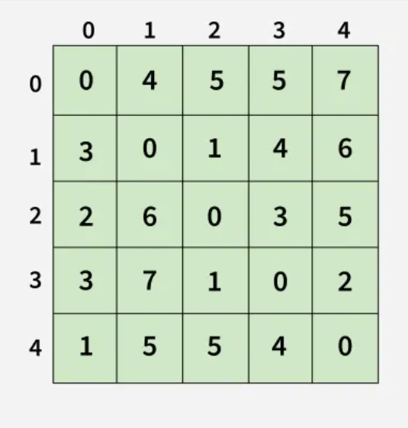
Each cell dist[i][i] in the output shows the shortest distance from node i to node j, computed by considering all possible intermediate nodes using the Floyd-Warshall algorithm.

Q13) Two steps of Johnson’s Algorithm:
1. Reweight the edges: Add a new vertex s with zero-weight edges to all vertices. Run Bellman-Ford to calculate vertex potentials h(v), then reweight each edge:
w'(u,v)=w(u,v)+h(u)-h(v)
2. Run Dijkstra’s Algorithm: Run Dijkstra from every vertex using the reweighted edges to find shortest paths between all pairs of vertices. Convert distances back to original weights.
d(u,v)=d'(u,v)-h(u)+h(v)
After applying first step we get updated weights of edges as follows:
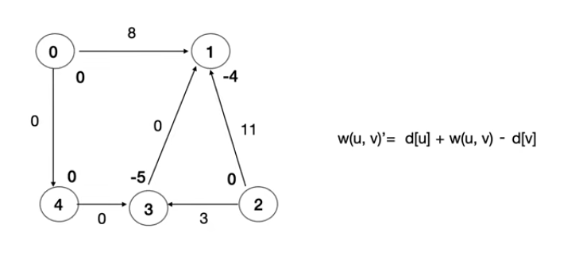
Q14) Answer: a
For any path $s=v_{0}→v_{1}→⋯→v_{k}=t$, the f-terms cancel in pairs:
$$w^{'}\left(\text{path}\right)=w\left(\text{path}\right)+f\left(s\right)-f\left(t\right)$$changes by the same constant $f\left(s\right)-f\left(t\right)$, so the shortest one stays shortest, for any f. (This is the reweighting trick in Johnson's algorithm.)
Q15)
Node (x,y) | Heuristic value (h(n))  Floor (Euclidian distance between Goal G (14,9) and given node.)
- (4,5) | 10
- (7,9) | 7
- (7,6) | 7
- (9,4) | 7
- (11,8) | 3
- (14,9) | 0
A* algorithm:
At each step, A* calculates a total cost value f(n) for every neighbouring node n using the following formula:
f(n)=g(n)+h(n)
- g(n): The exact cost of the path from the starting node to the current node n.
- h(n): The heuristic estimate of the cost to get from node n to the final goal.
- f(n): The total estimated cost of the cheapest path through node n.
The algorithm always prioritizes expanding the node that has the lowest f(n) value.
After implementing the algorithm minimum path comes out to be:
S(4,5) => (7,6) => (11,8) => G(14,9)

